**National University of Computer and Emerging Sciences**



**Lab Exercise 05**

*for*

# Web Programming

# Spring 2024

**FAST School of Computer Science**

# LABORATORY OUTCOMES

The practical/exercises in this section are psychomotor domain Learning Outcomes (i.e. subcomponents of the COs), to be developed and assessed to lead to the attainment of the competency.

This Course is designed to take the students full adventure of “**Full Stack Web Development**.”

**Today’s Agenda**

Module 1: JavaScript.

## Module 1: Playing with Java Script

* JavaScript is the world's most popular programming language.
* JavaScript is the programming language of the Web.
* JavaScript is easy to learn.

# Why Study JavaScript?

JavaScript is one of the 3 languages all web developers must learn:

1. HTML to define the content of web pages
2. CSS to specify the layout of web pages
3. JavaScript to program the behavior of web pages

Part-III

* **JS Query Selector:**

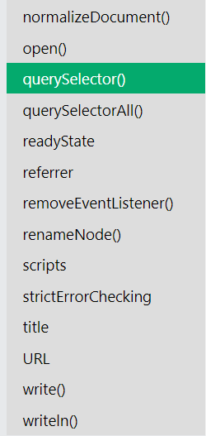

* **JS Data Types:**

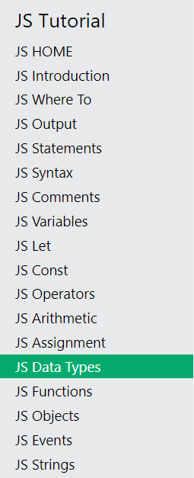

* **JS Loop For:**

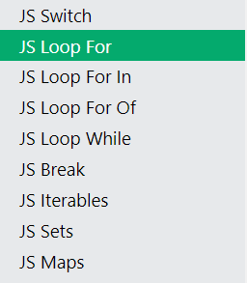

**JS HTML DOM:**

* <https://www.w3schools.com/js/js_htmldom.asp>

https://www.w3schools.com/js/default.asp

**You are done with your exercise(s), make your submission on Classroom.**

**BEST WISHES**

**References**

*W3Schools free online web tutorials*. Choose a Bootstrap Version (3, 4 or 5). (n.d.). Retrieved February 22, 2022, from <https://www.w3schools.com/bootstrap/bootstrap_ver.asp>

JavaScript tutorial. (n.d.). Retrieved February 22, 2022, from <https://www.w3schools.com/js/default.asp>